DecidR Data Model Design
Version: | 1.0
Author(s): | MF, DH
Created: | 05/05/2009

Version | Date | Author(s) | Changes
1.0 | 5/7/2009 | MF, DH | Initial version.
1.1 | 24/7/2009 | TK | Database Design corrections, minor changes in the document structure
Contents
1. Package Overview 3
1.1. Facades 3
1.2. Filters 3
1.3. Dwdl 4
1.4. Transactions 4
1.5. Commands 4
1.6. Entities 4
1.7. Exceptions 4
1.8. Permissions 4
1.9. Reveng 4
1.10. Logging 4
2. Facades 5
2.1. Description 5
2.2. Facades Overview 6
2.2.1. UserFacade 7
2.2.2. TenantFacade 7
2.2.3. WorkflowModelFacade 8
2.2.4. WorkflowInstanceFacade 9
2.2.5. WorkItemFacade 9
2.2.6. SystemFacade 9
3. Transaction Management 10
3.1. Goal 10
3.2. Hibernate Transaction Coordinator 11
3.2.1. Running transactional commands 11
3.3. Transactional Commands 12
3.3.1. Events 12
3.3.2. AbstractTransactionalCommand 12
3.3.3. AclEnabledCommand 12
3.4. Usage 13
4. Access Control 16
4.1. Description 16
4.2. Permission 17
4.3. Roles 17
4.4. Asserters 17
4.5. AccessControlList 18
4.5.1. ClearRules 18
4.5.2. SetRule 18
4.5.3. Allow 18
4.5.4. IsAllowed 19
4.6. Usage 19
5. Filter 21
5.1. Description 21
5.2. Paginator 21
5.3. Usage 22
6. Database Design and Hibernate Mappings 23
6.1. Database-Schema 23
6.2. Mapping 23
6.3. Reverse Engineering Strategy 23
6.4. Database Schema 25
7. Logging 35

Package Overview
The following diagram provides a rough overview of the DecidR package structure and its dependencies:

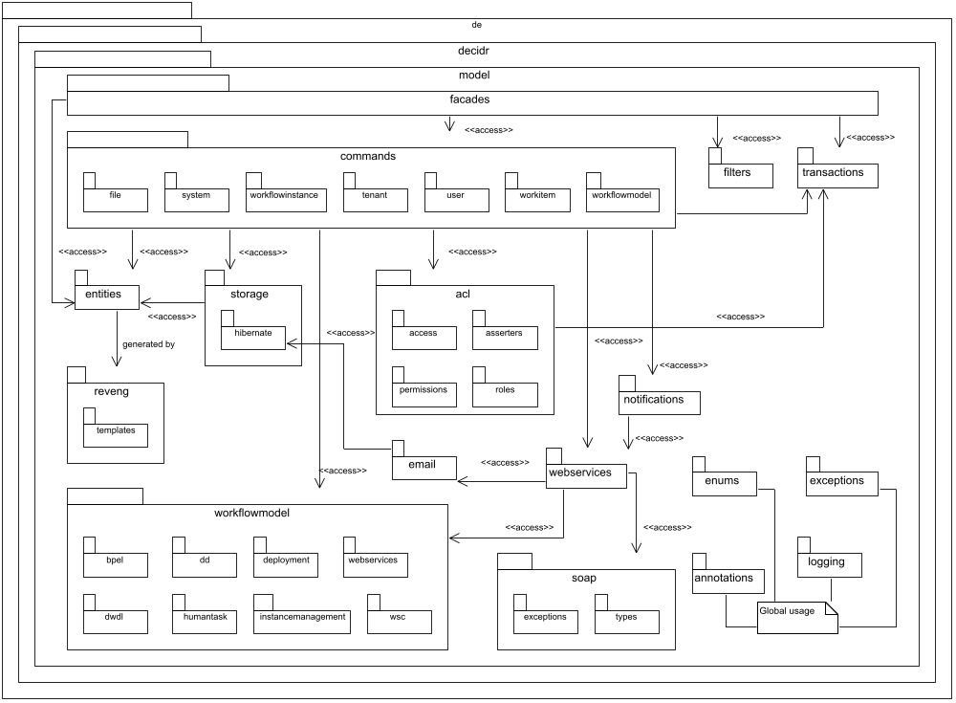
Figure 1: package overview

Facades
The facades package contains facade classes that interface with other system components such as Web services or servlets. The methods provided by the facades internally use one or several Commands which implement the actual functionality. The commands are executed by a transaction coordinator (see package transactions).

Filters

Filters are used to put constraints on database queries in order to reduce the number of returned objects. For instance, filters are applied if the objects to display on the GUI are spread over several pages. Keyword matching is another application.

Workflowmodel
The workflowmodel package contains interfaces and classes that handle transformation from DWDL to BPEL as well as communication with the Apache ODE during workflow model deployment and when starting new workflow instances. There are corresponding commands that depend on the components provided by this package.

Transactions
The transactions package contains interfaces and classes related to the execution of transactions, including the transaction coordinator.

Commands
A great deal of the DecidR business logic is contained within TransactionalCommands. Combined with the transaction coordinator, they make an implementation of the “command” design pattern (see Transaction Management).

Entities
The entities package contains all object-relational-mapping classes that are used by the DecidR model. These classes are generated by the Hibernate-Tools program hbm2java. Therefore, they do not hold any business logic and consist only of attributes, getters and setters. Their main purpose is to simply hold data that is retrieved from and saved to the database.

Exceptions
The package exceptions contains all exceptions thrown by the model.

Acl
The acl package contains everything related to access control, permission checking, etc.

Reveng
The reveng package contains the custom ReverseEngineeringStrategy that is used to generate Java classes from the DecidR database schema.

Logging
As of now, the logging package only contains the DecidR default log4J logger. All Java-based system components may use this logger to store logs in the DecidR database.

Webservices
This package contains web service interfaces, clients and JAXB wrappers for incoming and outgoing web service messages.

Soap
Contains classes needed for web service communication such as POJO representations of XML documents and wrappers for Java exceptions.

Email
The mail backend which is used by the Email web service is currently the only class in this package.

Annotations
Contains custom Java annotations for the DecidR project. Consult the Javadoc for each annotation to learn more.

Notifications
Lacking a proper template system for notification emails, a provisional mechanism for sending out such emails has been implemented here.

Facades

Description
The facades provide a simplified interface to all operations that require read from or write to the database. The facades also take care of transaction management, so the caller may assume that each method call equals one transaction.
Whenever the facade methods return complex objects, Hibernate managed entities are returned. Due to Hibernate lazy loading, accessing certain properties of these objects can lead to LazyInitializationExceptions. In general, all properties that are not primitive types are affected. This includes byte arrays, lists, sets and other Hibernate entities. All properties of such a type must be explicitly pre-loaded by the facade and are mentioned in the facade method comment.
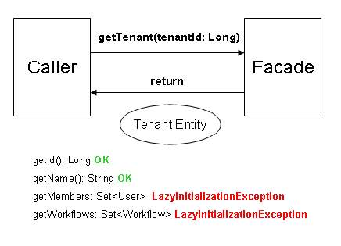
Figure 2: Hibernate lazy loading hazards

The current caller is identified by the actorId property; this id is mainly used for permission checks. Most of the time, it simply identifies the user that is requesting an operation. For instance, the approveTenants method can only be successfully executed if the actorId of the TenantFacade is set to the super admin’s user id.

Facades Overview
Currently there are six facades. Each facade deals with a category of objects (tenants, users, workflow models…). The facade constructors accept a single parameter, the actorId. The operations of the facade are executed under the context of the given actorId.

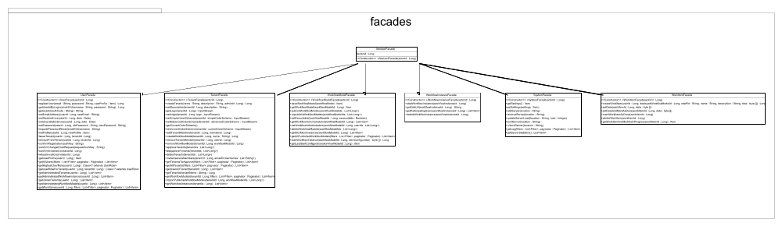
Figure 3: facades package
Previously this section contained a more detailed description of some facade methods, but these have been removed in favor of JavaDoc which is much easier to maintain than this document.

Transaction Management
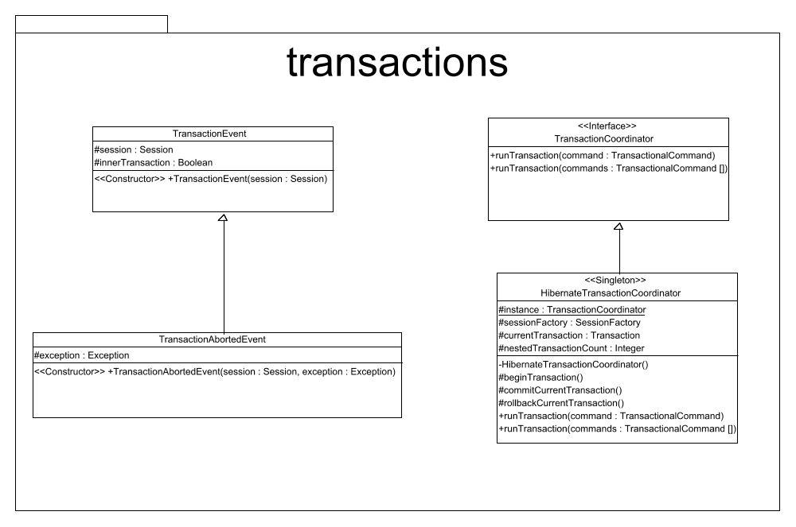
Figure 4: transactions package

Goal
The database access performed by the facade methods must take place under ACID semantics. To achieve this without a lot of code redundancy through transaction demarcation, the facades delegate the actual work to TransactionalCommand objects. Therefore the facades take on the client role in terms of the command pattern. An additional benefit of this approach is that adding permission checks to the façade operations becomes trivial:

public void deleteTenant(Long tenantId) throws TransactionException {
DeleteTenantCommand command = new DeleteTenantCommand();
command.setRole(new UserRole(this.actorId));
command.setPermission(new TenantPermission(tenantId));
command.setTenantToDelete(tenantId);

HibernateTransactionCoordinator.getInstance().runTransaction(command);
}



Facade

OperationXY()
command XY
OperationXY

{
HTC.runTransaction(commandXY) }

HibernateTransactionCoordinator (HTC)

Hibernate Transaction Coordinator
Following the command pattern, the HibernateTransactionCoordinator takes on the role of invoker. The transaction coordinator is responsible for explicitly beginning, committing or rolling back transactions using Hibernate. Additionally, the transaction manager supports nested transactions on the application level. If a transaction is started within an enclosing transaction, the transaction manager will delay the commit until the enclosing transaction finishes. This simple implementation allows for nested transactions by giving up the durability property of all inner transactions.

Running transactional commands
The transaction coordinator offers the method runTransasction which can be used to run one or more TransactionalCommands. If an array of TransactionalCommands is passed to this method, they are executed sequentially in “foreach” order within a single transaction.

Transactional Commands
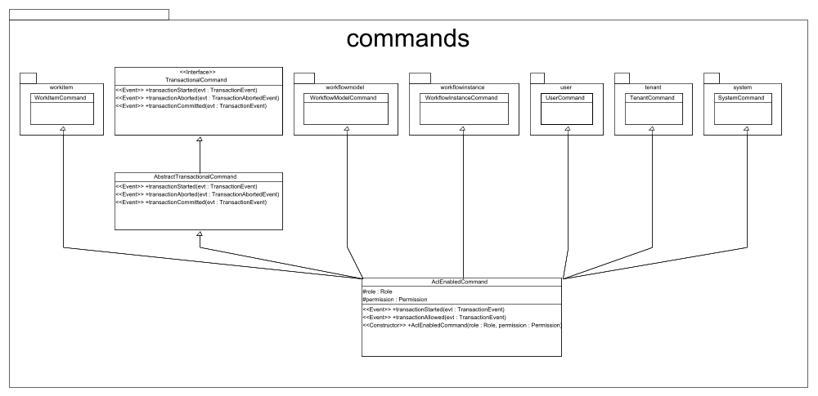
Figure 5: command package
An instance of TransactionalCommand is where the actual magic happens: it takes on the role of receiver in terms of the command pattern. All database access should take place within commands. Through sub classing, multiple commands can share the same attributes or functionality.

Events
TransactionalCommand defines the following events which are invoked by the transaction coordinator:

TransactionStarted
Called right after the transaction has been started by the transaction coordinator, this is where the command may manipulate the database. To do so, the event object provides the current Hibernate Session object. If this method throws an exception, the transaction is rolled back.

TransactionAborted
Called after the transaction has been rolled back, the command may use this method to react to a rollback (e.g. by logging the exception that occurred).

TransactionCommitted
This method is called after the transaction has been successfully committed. Unless the event is part of a nested transaction, the command may assume that its changes have been applied to the database.

AbstractTransactionalCommand
For convenience, this class provides empty implementations of the TransactionalCommand interface methods.

AclEnabledCommand
AclEnabledCommand is an abstract base class for all commands that require an additional permission check before modifying the database. It performs a simple query to DefaultAcccessControlList.isAllowed in its transactionStartedMethod, then executes its transactionAllowed method if and only if isAllowed returns true.
As a consequence, commands derived from AclEnabledCommand must override the transactionAllowed method instead of transactionStarted.

Usage
(see next page)
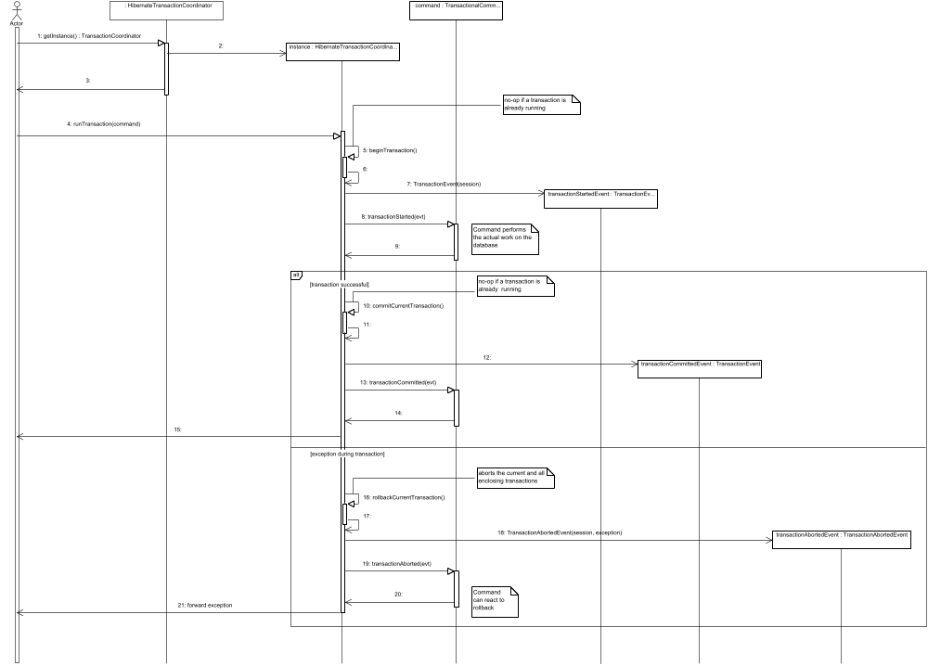
Figure 6: standard transaction
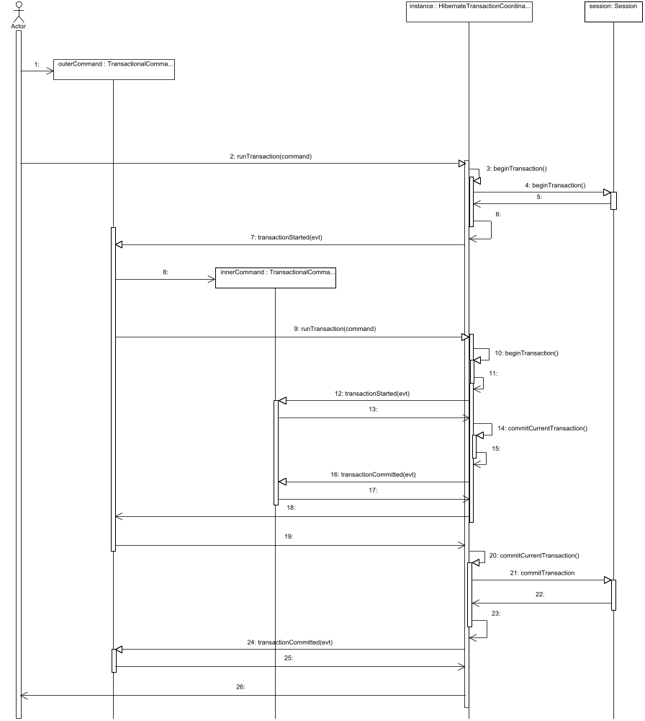
Figure 7: nested transaction

Access Control

Description
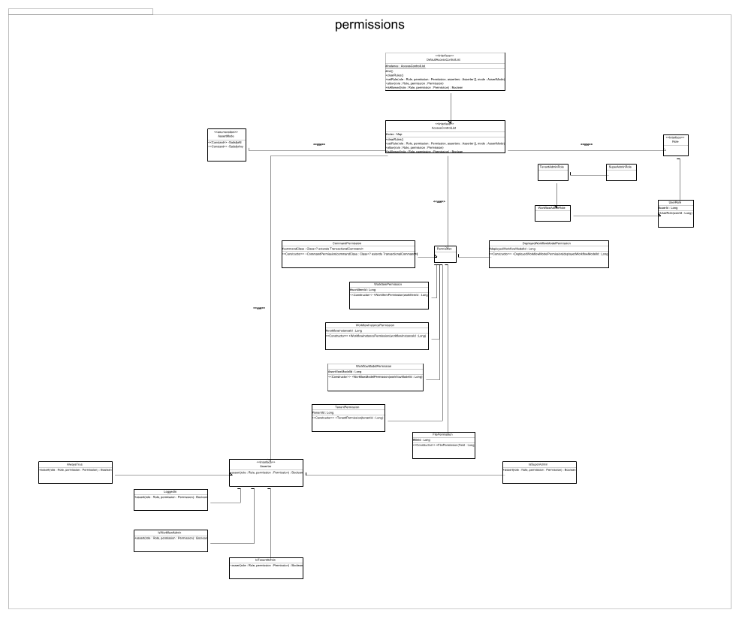
Figure 8: permissions package

Our approach to access control is based on four basic concepts:
- A centralized access control list that holds the access rules
- Permissions that represent things to which access is granted or denied such as files, commands and resources.
- Roles that identify persons, principals or systems that request access to permissions.
- Asserters that define the conditions under which a role has access to a permission.

The rules held by the access control list are mappings from (role, permission) to a set of asserters that decide whether or not access to the permission is granted to the role.

Permission
A Permission is an object under access control. It is uniquely identified by its name attribute.
The DecidR Permission is an extension of the java.security.BasicPermission class, which comes with a naming mechanism that is similar to Java namespaces. For instance, a Permission representing a particular TransactionalCommand simply uses the fully qualified class name as unique identifier.

Example: (“de.decidr.model.commands.tenant.DeleteTenantCommand”)

Identifying a Permission by its name allows externalizing permission definitions to the database with little effort in the future. The following database objects are identified by their table name and their id:

- WorkflowInstancePermission
- DeployedWorkflowModelPermission
- WorkflowModelPermission
- FilePermission
- TenantPermission
- WorkitemPermission

Roles
Roles represent the person / system / principal that requests access to a particular Permission. In the case of UserRole, the user is identified by his user id.

Asserters
An Asserter checks whether certain conditions are met (which may depend on the requesting Role and / or requested Permission). The Asserter interface defines a single method assert(role: Role, permission: Permission) that returns true if and only if the asserter grants the given role access to the given permission.

AccessControlList
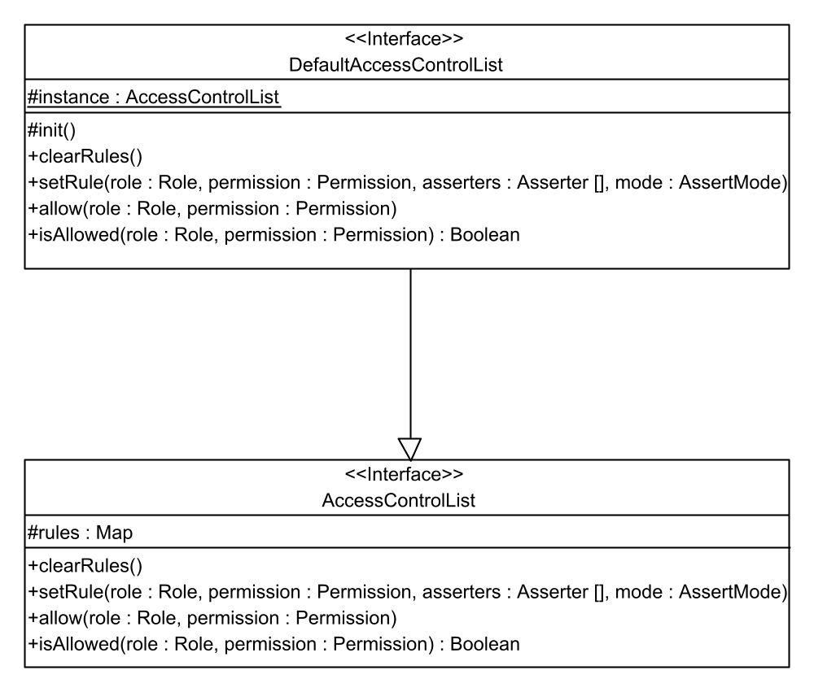
The ACL is basically a collection of access rules and acts a whitelist. Its main purpose is to provide a central place where rules are defined and queried. Its public methods are:

ClearRules
Removes all rules from the ACL.

SetRule
Adds a rule to the ACL. For each pair of Role / Permission only one rule can exist, where each rule may define multiple Asserters. The AssertMode parameter defines whether all assertions or only one of them must return true in order to grant access to the requested Permission.

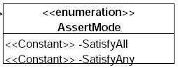

Allow
This convenience method adds a rule that grants a role access to a Permission without any special conditions.

IsAllowed
The isAllowed method checks whether the given role has access to the given permission by “asking” the associated asserters. If no rule has been defined for the given role and permission, the ACL returns false by default.

Usage
The default access control list creates its rule set automatically upon instantiation by using the aforementioned methods, which should be sufficient. If need be, the rules could be externalized to a configuration file or the database with relatively small effort.

Adding permission checks to commands is simple. By using AclEnabledCommand one can set a role and permission before invoking the command, the permission check will then take place within the transaction without needing to take further action:
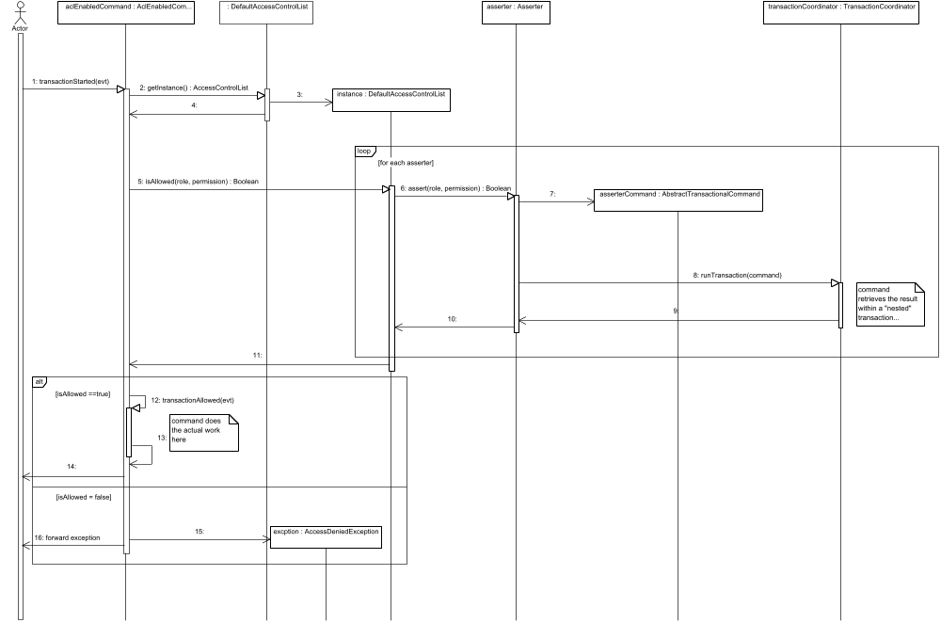
Figure 9: permission check

Filter

Description
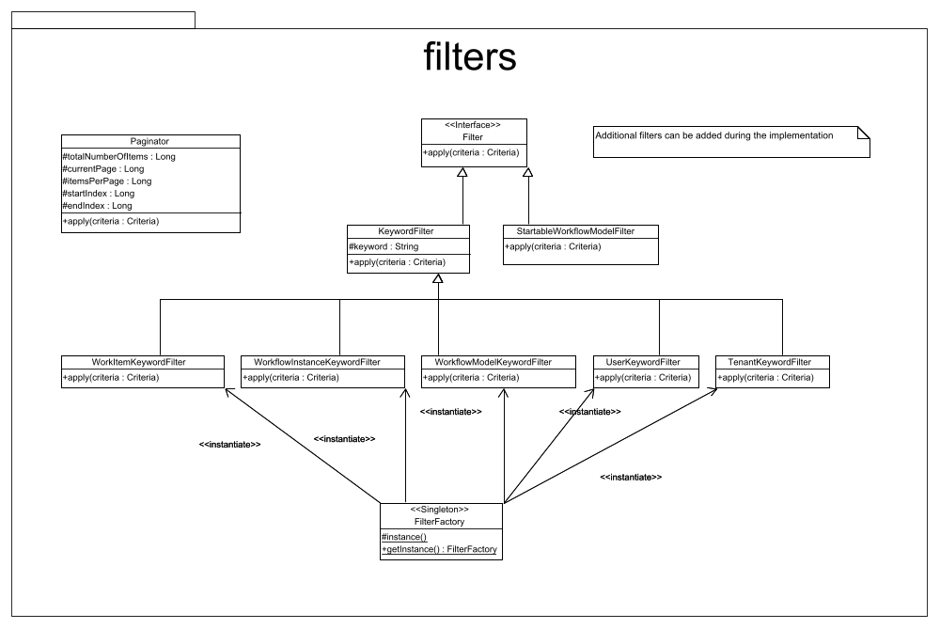
Figure 10: filters package
Filters can optionally be passed to facade methods when requesting (potentially) large sets of objects. The filters reduce the set of returned objects by adding instances of the Hibernate Criterion to a Hibernate Criteria object (which is a filtered database query) in the apply method.

A factory is used to create Filter instances.

Paginator
A recurring problem in the GUI is that you can’t display a list of tens of thousands of items at once, but they must be spread over several pages. Additionally, such queries would put a huge strain on the database.
The paginator basically behaves like a filter, but additionally retrieves the total number of items that are available. To avoid confusion with other filters, the paginator does not implement the Filter interface. This is due to the fact that a paginator must always be applied to Hibernate Criteria after all other filters have been applied.

Usage
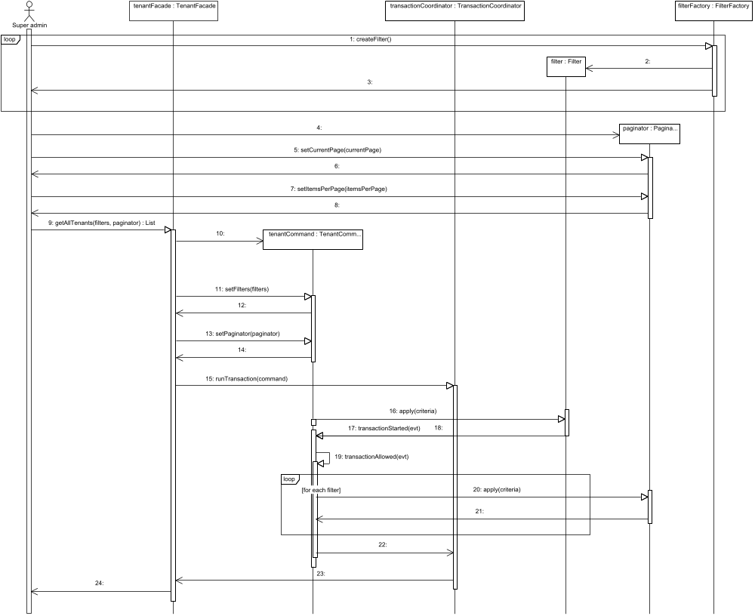
Figure 11: filter / paginator usage

Database Design and Hibernate Mappings

Database-Schema
The database schema contains a model of the DecidR “mini world” which includes the involved entities and the relations between these entities. It has been created using MySQL Workbench. Where required special views on the data have been created as well. More such views can be added with little effort in the future. Greater changes to the table structure should be avoided, though.

Mapping
Hibernate is used to map database entities to Java Beans. The mapping files are created by Hibernate-Tools using a custom reverse engineering strategy. The complete Java class generation process involves:

- Forward engineering the database schema to a local DBMS using the workbench or a *.sql file.
- Reverse engineering the database to Java classes and Hibernate mapping files using Hibernate-Tools.

Reverse Engineering Strategy

To customize the attribute names of the generated classes the de.decidr.model.reveng.DecidrReverseEngineeringStrategy must be selected in the Hibernate reverse engineering run configuration. The custom strategy behavior is very similar to the default strategy, save for the naming of properties that result from foreign keys.
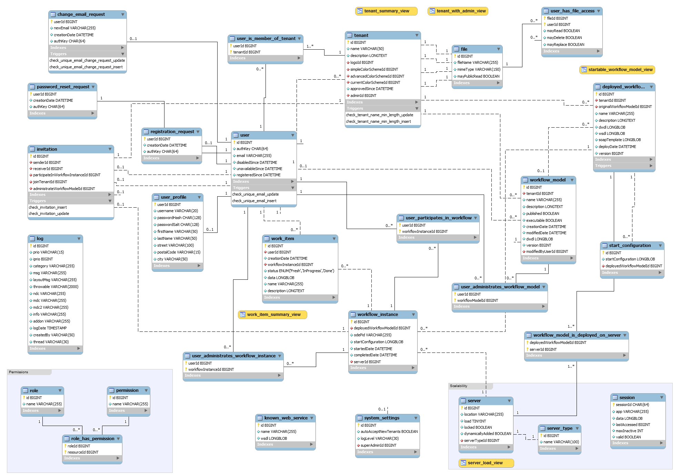
Figure 12: database schema

Database Schema

The following section describes roughly the main aspects of the tables in the DecidR database scheme. For further information please study the according code which should shed more light, if this not happened before.

“user”
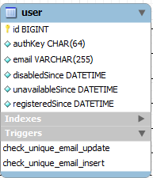
Figure 13: „user“ table

The “user” table contains all users of the system. Unregistered users are also in the table. All registered and unregistered users should have unique email addresses. Without completed user profile the user is considered unregistered. The “authKey” of an unregistered user is not NULL. The “authKey” is a random value used for authentication and registration of an unregistered user. If the user is already registered the “authKey” value is NULL. If “disabledSince” is not NULL, then the according user was disabled by super admin. If the user is flagged as unavailable, “unvailableSince” is not NULL. If “registeredSind” is NULL, then the user has never been successfully registered. After successful registration the registration date is inserted into “creationDate”.

“user_profile”
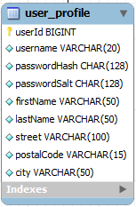
Figure 14: table „user_profile“

“user_name” should be unique. All constraints regarding prohibited characters in the user name are checked by the application logic. “passwordHash” and “passwordSalt” are used to store the password. The system does not store the password in plain text, but uses a double hash and a salt to make attacks on the hashed password exceedingly difficult to penetrate.

“file”
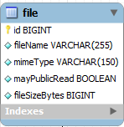
Figure 15: table „file“

The “file” table contains information about known files in the system. The files are not stored physically in the database, but only as references to them. Internally the file is known through the unique “id”. The “mimeType” is provided by the uploader. “mayPublicRead” contains information about whether the according file is accessible by anyone or not.

“tenant”
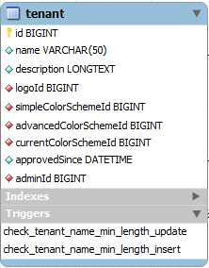
Figure 16: table „tenant“

The “tenant” table contains, as the name suggests, all information about tenants. “logoID” points to the tenant logo file. There are two different color schemes simple and advanced color schme, which are stored under “simpleColorSchemeId” and “advancedColorSchemeId”. The “currentColorSchemeId” contains the currently selected color schme. If the value of the “approvedSince” is NULL, then the tenant still need approval by the super admin. The “adminId” contains the ID of the super admin.

“user_is_member_of_tenant”
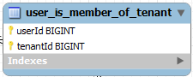
Figure 17: table "user_is_member_of_tenant"

The “user_is_member_of_tenant” is a N:M relation. A user can be member of one or more tenants. The tenant in the table can have one or more users.

“workflow_model”
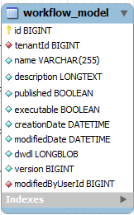
Figure 18: table "workflow_model"

The “workflow_model” table contains information about tables which can be edited by the according users. The “tenantId” contains information about whom this workflow model affiliates. “published” declares whether the workflow is published or not. If “executable” set to TRUE, the workflow model is allowed to be started by the user. This also depends on the question, whether a deployable version of the workflow model exists. The “version” is incrementented on every stored change of the workflow model. “modifiedByUserId” contains the userId of the last user, who modified the workflow model.

“deployed_workflow_model”
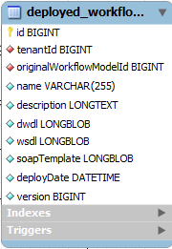
Figure 19: table "deployed_workflow_model"

The table “deployed_workflow_model”, as the name suggests, contains information about deployed workflow models. The information in the according records is a copy of data available in “workflow_model”, with the difference that they can be deployed. “originalWorkflowModleId” is NULL, if the original workflow model has been deleted or is no longer available. “originalWorkflowModelId” is null, if the orginal workflow model has been deleted or is no longer available, but the instance still exists.

“server”

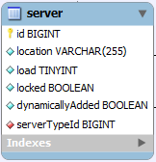
Figure 20: table "server"

The „server“ table contains information about available server. The “location” depends on the “serverTypeId”. It can be URL in case of the web portal or something else in case of ODE or ESB server. “load” ranges from 0 to 100 percent. If “locked” is set to TRUE, then new workflow models cannot be deployed on the according server. If “dynamicallyAdded” is set to true, then the server can locked etc.

„server_type“
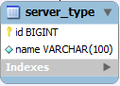
Figure 21: table "server_type"

„server_type“ table contains additional information about the server.

“workflow_instance”

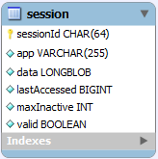
Figure 22: table "workflow_instance"

“deployedWorkflowModelId” is a reference to the workflow instance by which it was deployed. “odePid” is the Apache ODE PID of according workflow instance. This PID is provided by Apache ODE. There is no equivalent ID in DWDL. The instance is identified trough the “deployedWorkflowModelId” and “odePid”. The combination of them is always unique. “startConfiguration” contains raw data about start configuration. If “startedDate” is NULL, then the workflow instance is waiting to be started. If “completedDate” is not NULL, the workflow instance is no longer running.

“work_item”
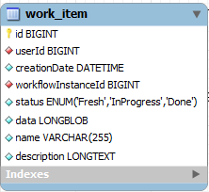
Figure 23: table "work_item"

A work item is a human task. This human task is owned by the “userId”. This task is also part of a workflow instance in the “workflowInstanceId”. The human task can have three states: fresh, in progress and done. The “data” is raw XML data, that contains information about the properties which can be edited by the according user. This data is provided by the web portal and the human task editor.

“user_administrates_workflow_model”
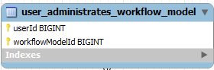
Figure 24: "user_administrates_workflow_model"
“user_administrates_workflow_model” is an N:M relation. The user can manage one or more workflow models. A workflow model can be managed by one or more users.

“user_participates_in_workflow”
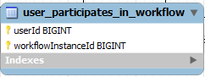
Figure 25: table "user_participates_in_workflow"

“user_participates_workflow_is a N:M relation. The user can participate in one or more workflow instances. A workflow instance can have one or more participants.

“change_email_request”
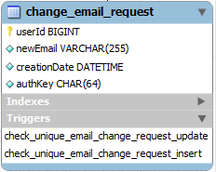
Figure 26: table "change_email_request"

A user can have at most one email request in case he or she wants to change the email address. The “newEmail” is the desired email address of the user in “userId”. “creationDate” is the time when the request was made up. “authKey” is used to authentificate the email address change within the application. The user should know this key in order to perform the email address change. Through the constraints provided by the DB, it is always granted that the desired email address is unique and not already existing.

“registration_request”
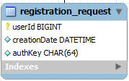
Figure 27: table "registration_request"

The „registration_request“ table is used for registration requests and also contains „authKey“ as described above.

“invitation”
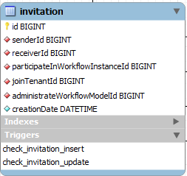
Figure 28: table "invitation"

There are three types of invitations “to join a tenant”, “to join a tenant and participate in a workflow” and the last “to join a tenant and administrate a workflow”. The column which is not NULL determines the type of invitation.

“session”

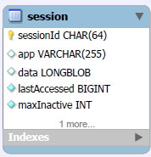
Figure 29: table "session"

The table “session” is indented for scalability of the system.

“user_has_file_access”
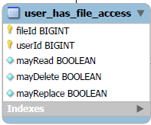
Figure 30: table "user_has_file_access"

“user_administrates_workflow_instance”

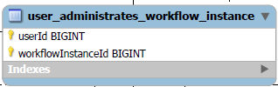
Figure 31: table "user_administrates_workflow_instance"

This table contains as the name suggests information about users who administrate one or more workflow instances.

“known_web_service”

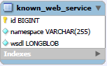
Figure 32: table "known_web_service

The “known_web_service” contains all known web services used in the application

start_configuration
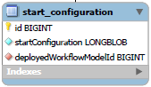
Figure 33: table "start_configuration"

The “start_configuration” table contains information about deployed workflow model. The is only entity pro deployed workflow instance.

system_settings

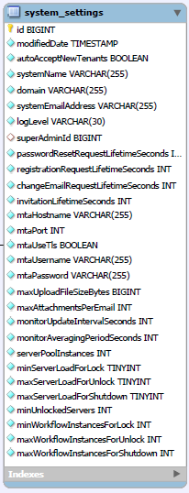
Figure 34: table "system_settings"

The column ‘autoAcceptnewTenants’ contains a value, whether the tenant should be activated by the super admin or not. ‘systemName’ column is for providing additional information about the system, e.g. operating system. ‘domain’ is essential for generating URL, which are referring to the system. ‘systemEmailAddress’ is the default reply address used by the system. ‘superAdminID’ is the ID from the super admin. All columns like `passwordResetRequestLifetimeSeconds`, `registrationRequestLifetimeSeconds`, `changeEmailRequestLifetimeSeconds`, ‘`invitationLifetimeSeconds` have influence on the decision, how long are the request valid. All the records in these columns are compared with now. It the value is below now – the request is not valid anymore and vice versa. `mtaHostname`, `mtaPort`, `mtaUseTls`, `mtaUsername`, `mtaPassword` are responsible for the settings in the Mail Transfer Agent. Basically this agent is used by the mail web service. `maxUploadFileSizeBytes` restricts the attachment size of the mails sent through the application. `monitorUpdateIntervalSeconds` is essential for the monitoring web service and restricts the time, how often the monitor clients will send server load data to the collector services. `monitorAveragingPeriodSeconds` correspondingly averaged time period when calculating the server load. `serverPoolInstances` is the number of server instances that should never be shut down automatically by the monitor service. `minServerLoadForLock` contains min values at which the load monitor service should lock be locked. All instances above this value are not allowed to be started. `maxServerLoadForUnlock` is the same, but for unlocking. `maxServerLoadForShutdown` If server load goes below this value, the load monitor will consider shutting down the affected server. minUnlockedServers` is the number of servers that should remain unlocked even if their load is above the value in the column ‘minServerLoadForLock’. The value in the ‘minWorkflowInstancesForLock` gives the number of max. workflow instances, which can be saved separately on the same time. If the actual value of instances is above, the action will be locked by the load monitor. `maxWorkflowInstancesForShutdown` is another limit, which causes to shut down, if the provided number of workflow instances is reached.

`workflow_model_is_deployed_on_server`

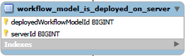
Figure 35: "workflow_model_is_deployed_on_server"

`workflow_model_is_deployed_on_server` provides the system with information on which server the workflow model was deployed.

`log`
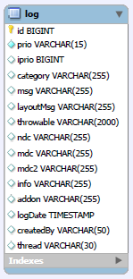
Figure 36: table "log"

‘log’ is used by the JDBC Appender for logging.

`password_reset_request`
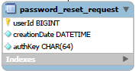
Figure 37: table "password_reset_request"

`password_reset_request` is intended for password resets. All you need to know is the auth key in your email.

`login`
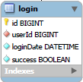
Figure 38: table "login"

„login” is intended for logging of successful or failed login. This data can be analyzed or used for further purposes, like preventing brute-force search etc.

“server_load_view”

`server_load_view` is intended for retrieving a server load summary including the number of deployed workflow instances.

“work_intem_summary_view”

`work_item_summary_view` contains roughly the information what the tenant admin allowed te see in the web portal.

Logging
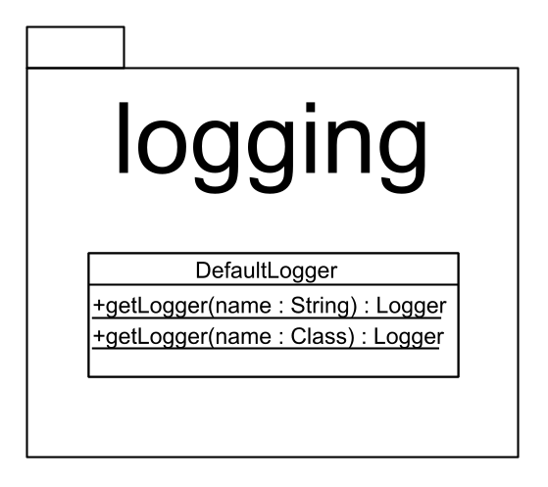
Figure 39: logging package
DecidR relies on Log4J version 1.2. To achieve centralized logging, the DecidR model provides a default logger that uses an extended JDBCAppender that writes all log entries to the database.
In the future, the logging system may be extended by introducing a global log level that is set by the super admin. In order to process log level updates, system components will have to provide an interface for the “log level updated” event. Until then, every system component has its own log level that can be changed manually by editing the corresponding log4j configuration file.

Command design pattern: http://en.wikipedia.org/w/index.php?title=Command_pattern&oldid=288219003
MySQL Workbench, Open Source Edition: http://www.mysql.com/products/workbench
Log4J JDBC appender: http://www.dankomannhaupt.de/projects/index.html

